**Homework 1**

***Question 1.*** Consider the platform model we studied in the lecture. Sellers are of two types, $c_{L}$ and $c_{H}$. Buyers are also of two types, $v_{L}$ and $v_{H}$. Each type consists of half of the population in each group. The modification in this exercise is that now every pair of match generates positive surplus, i.e., $v_{H}>v_{L}>c_{H}>c_{L}$. We still assume that there exists a decentralized market where agents randomly match and the surplus is evenly split between a buyer and a seller.

**a.** Write down all agents’ payoffs in the decentralized market if the platform is absent.

***Answer.*** From the question, it is clear that because of $v_{H}>v_{L}>c_{H}>c_{L}$, every pair of matches generates a *positive surplus*. Also, considering the surplus is *evenly* split between a buyer and a seller, the payoffs of all agents should be:

* payoffs of $v_{H}$-type **buyers** are: $\left(v_{H}-c_{H}\right)/8+\left(v_{H}-c_{L}\right)/8$
* payoffs of $v_{L}$-type **buyers** are: $\left(v_{L}-c_{H}\right)/8+\left(v_{L}-c_{L}\right)/8$
* payoffs of $c_{H}$-type **sellers** are: $\left(v_{H}-c_{H}\right)/8+\left(v_{L}-c_{H}\right)/8$
* payoffs of $c_{L}$-type **sellers** are: $\left(v_{H}-c_{L}\right)/8+\left(v_{L}-c_{L}\right)/8$

**b.** Write down the total welfare in the decentralized market if the platform is absent.

***Answer.*** We can obtain the total welfare of the market by *directly summing* the payoffs of the agents in question a:

$${(v}_{H}-c_{H})/4+(v_{H}-c_{L})/4+(v_{L}-c_{L})/4+(v_{L}-c_{H})/4=(v_{H}+v_{L}-c_{H}-c_{L})/2$$

**c.** Now we introduce a profit-maximizing platform who acts as a dealer between buyers and sellers. What prices can the platform charge to segment the market so that only the more efficient types join the platform.

***Answer.*** The platform should charge buyers at $p_{B}={(v}_{H}+c_{H})/2$ and charge sellers at $p_{S}=\left(v_{L}+c_{L}\right)/2$ to let more efficient types join it, for the following reasons.

To make $v_{H}$-type buyers remain in the platform, there should be $v_{H}-p_{B}≥\frac{v_{H}-c_{H}}{2}$. To make $c_{L}$-type sellers remain in the platform, there should be $p_{S}-c_{L}≥\frac{v_{L}-c_{L}}{2}$. In order to maximize the profit, we want $p_{B}$ to be *as high as possible*, and $p_{S}$ to be *as low as possible*. So we have $p_{B}=\left(v_{H}+c_{H}\right)/2$, and $p_{s}=\left(v_{L}+c_{L}\right)/2$.

Based on the price, for $v_{L}$-type buyers: $v_{L}-p_{B}=v_{L}-\left(v_{H}+c_{H}\right)/2<\left(v_{L}-c_{H}\right)/2$ and for $c_{H}$-type sellers $p_{S}-c_{H}=\left(v_{L}+c_{L}\right)/2-c_{H}<\left(v_{L}-c_{H}\right)/2$. That ensures $v_{L}$-type buyers and $c_{H}$-type sellers *are unwilling to use the platform*.

So, the platform should charge buyers at $p_{B}={(v}_{H}+c_{H})/2$ and sellers at $p_{S}=\left(v_{L}+c_{L}\right)/2$ to allow $v_{H}$-type buyers and $c_{L}$-type sellers remain in the platform while ensuring $v_{L}$-type buyers and $c_{H}$-type sellers are unwilling to use the platform.

**d.** Verify that all types of agents have no incentive to deviate.

***Answer.*** I have proved it in question c. The platform charge buyers at $p_{B}={(v}_{H}+c_{H})/2$ and sellers at $p_{S}=\left(v_{L}+c_{L}\right)/2$.

For the $v_{H}$-type buyers and $c_{L}$-type sellers who remain in the platform, payoffs of $v_{H}$-type buyers are $v_{H}-p_{B}=\frac{v_{H}-c_{H}}{2}$, and payoffs of $c_{L}$-type sellers are $p_{S}-c_{L}=\frac{v_{L}-c_{L}}{2}$. The payoffs *are same as leaving the platform*. So, these two efficient types have no incentive to deviate.

For $v_{L}$-type buyers and $c_{H}$-type sellers who are unwilling to use the platform, payoffs of $v_{L}$-type buyers are $v_{L}-p_{B}=v_{L}-\left(v_{H}+c_{H}\right)/2<\left(v_{L}-c_{H}\right)/2$, and payoffs of $c_{H}$-type sellers are $p_{S}-c_{H}=\left(v_{L}+c_{L}\right)/2-c_{H}<\left(v_{L}-c_{H}\right)/2$. The payoffs of using the platform are *less than leaving it*. So, these two inefficient types have no incentive to deviate.

**e.** Does the platform make positive profit?

***Answer.*** Yes, the platform makes positive profits. Because: (1) $p_{B}-p_{S}={(v}_{H}+c_{H})/2-(v_{L}+c_{L})/2>0$; (2) based on question d, $v_{H}$-type buyers and $c_{L}$-type sellers will choose to trade in the platform, which means the number of trading in the platform is bigger than $0$.

**f.** Who are better off and who are worse off after introducing the platform?

***Answer.*** *All of the agents are worse off* after introducing the platform:

* For $v_{H}$-type buyers, their payoffs decrease from $\left(v_{H}-c_{H}\right)/8+\left(v_{H}-c_{L}\right)/8$ to $\left(v_{H}-c_{H}\right)/4$, and the difference is $\left(c_{L}-c_{H}\right)/8<0$.
* For $v_{L}$-type buyers, their payoffs decrease from $\left(v_{L}-c_{H}\right)/8+\left(v_{L}-c_{L}\right)/8$ to $\left(v_{L}-c_{H}\right)/$ 4, and the difference is $\left(c_{L}-c_{H}\right)/8<0$.
* For $c_{H}$-type sellers, their payoffs decrease form $\left(v_{H}-c_{H}\right)/8+\left(v_{L}-c_{H}\right)/8$ to $\left(v_{L}-c_{H}\right)/4$, and the difference is $\left(v_{L}-v_{H}\right)/8<0$.
* For $c_{L}$-type sellers, their payoffs decrease from $\left(v_{H}-c_{L}\right)/8+\left(v_{L}-c_{L}\right)/8$ to $\left(v_{L}-c_{L}\right)/4$, and the difference is $\left(v_{L}-v_{H}\right)/8<0$.

**g.** Is the total welfare enhanced after introducing the platform? Explain why.

***Answer.*** No, the total welfare *doesn’t change* after introducting the platform. As we computed in question b, before introducing the platform, the total welfare is:

$\left(v_{H}+v_{L}-c_{H}-c_{L}\right)/2$.

After introducing the platform, the total welfare should be the sum of all payoffs of buyers, sellers, and the platform, which is:

$$\left(v_{H}-c_{H}\right)/4+\left(v_{L}-c_{H}\right)/4+\left(v_{L}-c_{H}\right)/4+\left(v_{L}-c_{L}\right)/4+p_{B}/2-p_{S}/2$$

$=\left(v_{H}+v_{L}-c_{H}-c_{L}\right)/2$.

This is mainly because the free market equilibrium has reached market efficiency under the assumptions of this question. The introduction of platforms only transfers a certain amount of payoffs to the platforms without bringing more welfare.

***Question 2.*** Derive the demand curve with network effect.

***Answer.*** I perform a detailed derivation as taught in class, also using a fax machine as an example. The first is an introduction to the background of the model:

* Consider a monopoly selling fax machines at price $p$, with constant unit cost normalized to $0$.
* Fax machines are certainly subject to *network effects*: if you are the only one to own a fax machine, your fax machine is worthless.
* There is a mass 100 of consumers.
* Consumers differ in their valuations for network externalities.
* Assume that consumer $i$ has valuation $w_{i}$ for network effects, where $w_{i}$ is uniformly distributed on the segment $\left[0,100\right]$.

Based on these, we can give the consumer $i$’s utility :

$U_{i}=\left\{\begin{aligned}w_{i}f-p,if he purchases the fax machine \\ 0, otherwise \end{aligned}\right.$,

where $f$ denotes the *expected proportion of consumers*who will buy a fax machine. Then, the demand by consumer $i$ for a fax machine can be given by:

$q_{i}=\left\{\begin{aligned}0, if w_{i}f<p \\ 1, if w_{i}f≥p\end{aligned}\right.$.

To solve the demand curve, we can define the following two-stage game:

* the monopoly sets its price $p$;
* all consumers decide whether to purchase simultaneously.

We look for the subgame perfect equilibria of this game, which is different from all 0’s equilibria. It’s clear that all other equilibrium candidates will be interior, i.e., with $f∈(0,1)$. We first find a marginal consumer, and denote his valuation by $\tilde{w}$. $\tilde{w}$ satisfies

$\tilde{w}f-p=0$, i.e., $\tilde{w}f=p$.

By definition of $\tilde{w}$: all consumers with $w_{i}≥\tilde{w}$ will purchase in a Nash equilibrium and all consumers with $w_{i}<\tilde{w}$ will not purchase in a Nash equilibrium. Therefore, if $f$ and $\tilde{w}$ arise in a Nash equilibrium, it has to be that:

$100f=100-\tilde{w}$, i.e., $\tilde{w}=100(1-f)$.

Combining the two above conditions, we can get rid of $\tilde{w}$, and conclude that $f$ can be sustained in a Nash equilibrium if and only if:

$$p=100f(1-f)$$

In other words, marginal individual’s valuation $\tilde{w}f=p=100f(1-f)$. Then we can draw the demand curve with network effect in Figure 1., the vertical axis is marginal consumer’s willing to pay, which is price, and the horizonal axis is the demand quantity.

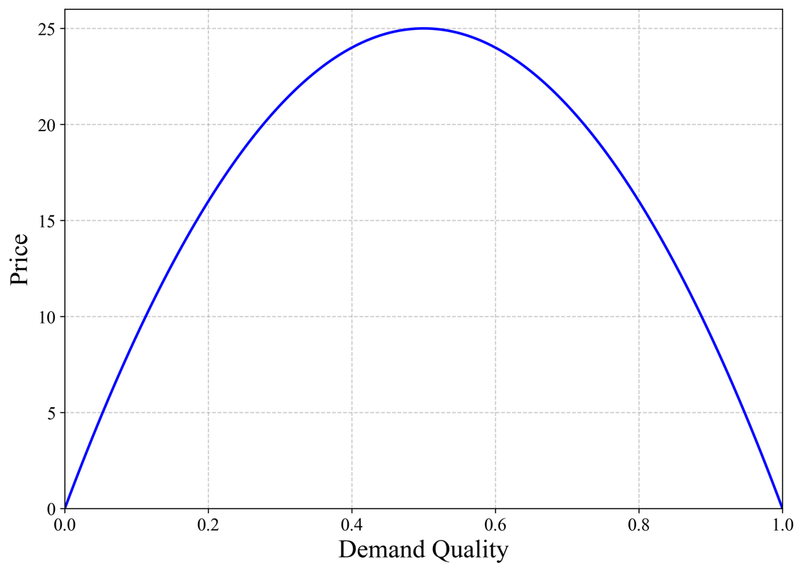

Figure 1. The demand curve with network effect.

***Question 3.*** Read the attached article about Ebay and address the following questions:

**a)** Comment on entrant’s idea that lowering or eliminating listing fees is a good way to attract more sellers.

***Answer.*** For sellers, the lower listing fees on the eBay platform will make it more attractive, which will in turn increase the number of sellers and further expand the platform's application volume through the network effect. In theory, this distributes some of the platform's revenue among the sellers, thereby widening the user base and boosting profit margins. This strategy enables a greater number of sales, but the platform also needs to accurately assess the reduction to ensure overall profitability.

**b)** Explain the nature of the network externalities in this market, both positive and negative.

***Answer.***

Positive:

* More buyers ⇒ Quality items are more likely to be sold ⇒ Attract more sellers by placing a wider variety of quality items ⇒ Generate more buyers.
* More buyers ⇒ Generate more comments ⇒ Better monitoring ⇒ Higher quality of seller's products ⇒ more buyers.

Negative:

* More sellers ⇒ High homogenization and price pressure ⇒ Very low prices ⇒ Fewer sellers.
* More branded merchants ⇒ More low-cost, low-priced products ⇒ Creative individual sellers disappear ⇒ Branded manufacturers lose the incentive to innovate ⇒ Product quality declines

**c)** In light of your answer to part b), comment on the strategy of entrants targeting specific categories of goods, as opposed to tackling eBay head-on across all categories.

***Answer.*** Considering the existence of positive network externalities, it is difficult for entrants to break through on a wide range of goods, as many goods on eBay have already accumulated a large user base of buyers and sellers. On the other hand, it is easier to find those niche products that have not yet appeared on eBay or those products whose sales have been seriously declining due to negative network externalities and to open up a path of specialization so that it will be easier to build up users at the initial stage and achieve a breakthrough.